ITR

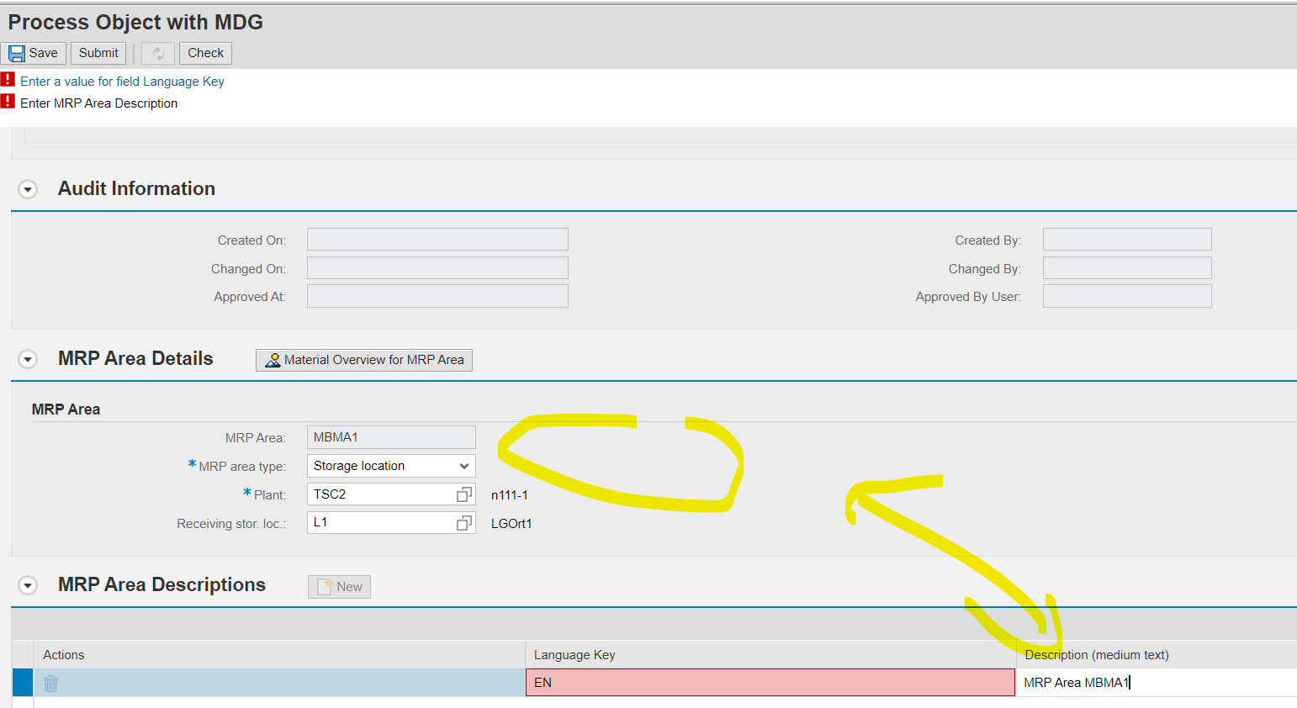
Is it correct that we don’t have a description field in the MRP Area Details?

Cannot Create new language dep descriptions …

